**Deployment Manual**

* Download the project from the given GitHub link:

**Link:**  https://github.com/KoushikK01/Event_Managment_System.git

* Open Spring Tool Suite (STS) and visual studio to import the downloaded file.
* Go to your application properties and change the credentials according to your system.
* The port number we have given is 9092, if this port is busy, change the port number.
* In MY SQL Command line create a database as Event_managment and save.
* Run the project as spring boot application as shown below.

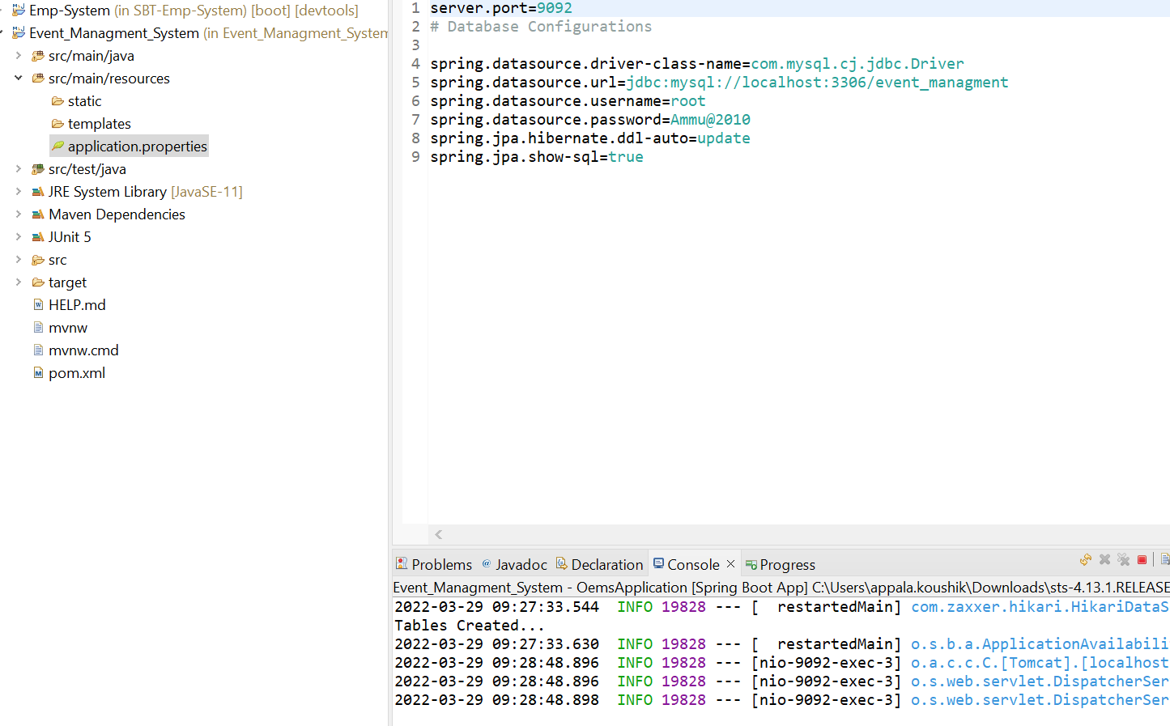

* Once, it shows Tomcat started on port number has started in the console, open up your web browser and type localhost:9092/ (or localhost: port number/).

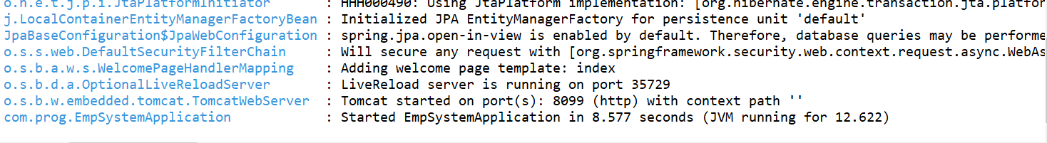

* Once it gets loaded, then you can download the file of front end and start running in the vs code and command line so that the local host can be generated and your project will be in running status
* 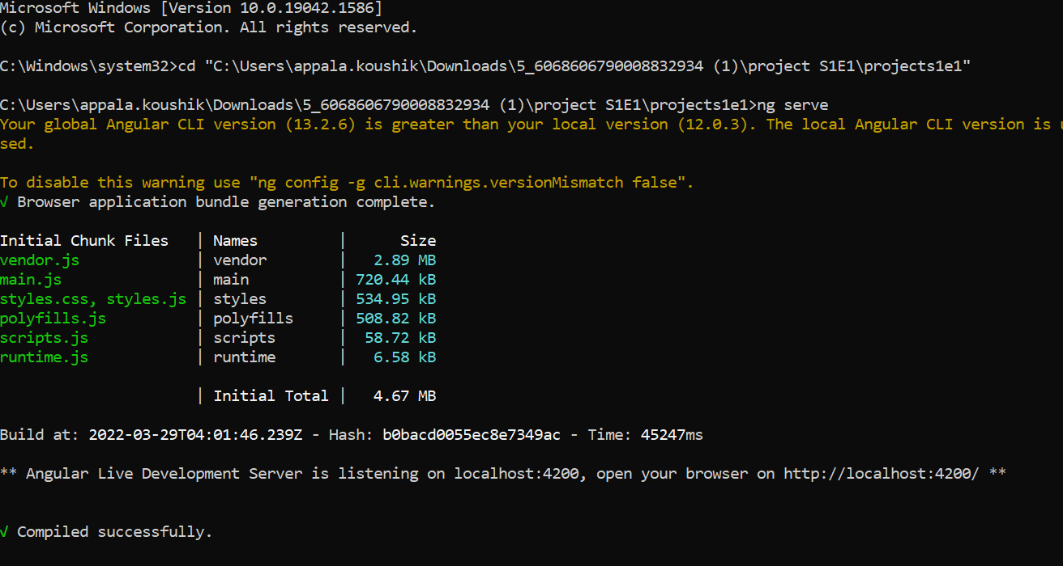
* By this result the project will be running whenever we open localhost:4200 in web the project will be opened

